Please OBJECT to Knockodhar Wind Farm (ECU00002153)
Send objections to: econsents_admin@gov.scot
Deadline - 21 July 2023

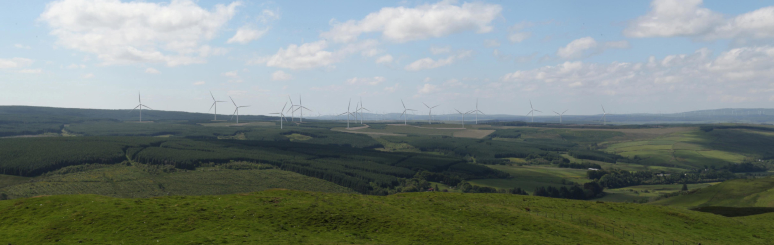
Knockodhar Wind Farm viewed from Auchensoul Hill

Knockodhar Wind Farm (50MW) is a new wind farm proposal adjacent to the village of Pinwherry, 3.5 km south-west of Barr, in South Ayrshire. It consists of 16 x wind turbines (149.9 m - 200 m high to blade tip), a substation (132 kilovolt), an energy storage system (ESS) and compound.

The Applicant is a partnership between REG Power Management Limited (REG) and ESB Asset Development UK Ltd (ESB). REG is a UK renewable energy company. ESB is Ireland’s part state-owned electricity utility company and owner of Derrybrien Wind Farm. Derrybrien is remembered for its notorious peat landslide killing 50,000 fish and devastating the environment in Ireland in 2003, for which ESB were fined millions of Euros.

The documents relating to the Knockodhar Wind Farm application can be found at the Energy Consents Unit (search for Knockodhar).
Applicant's website: Knockodhar Wind Farm

Please note: This application has changed considerably from the original so please discard the previous set of bullet points. Ideas for objections below are not comprehensive and do not cover everything.

Ideas for objections
1. Landscape and visual
• Situated within the South Ayrshire Plateau Moorlands with Forestry and Wind Farms Landscape Character Type (LCT 18a), the proposed development will have a significant effect on the landscape character. It will also have a localised and significant effect on part of the neighbouring Intimate Pastoral Valley (LCT 13).

• Significant localised effects are expected on the views at Pinwherry because of the proposed abnormal indivisible loads (AIL) delivery track (see image below). No significant effects have been concluded for Barr or Colmonell although the turbines are theoretically visible from here. There will be significant effects on the views of seven properties within 2.5 km of the proposed development.

• There are a high number of recreational routes in this area. The views from six of these routes will suffer significant effects and include cumulative visibility of Mark Hill, Hadyard Hill and Assel Valley wind farms, and the Clauchrie application. The routes impacted are as follows: Whithorn Way, Core Path SA51, Core Path SA61, Girvan Trails, Right of Way SKC3 and Scottish Hill Track 68. Significant visual effects are also expected from stretches of the A714 and B734.

• There will be significant effects on Dinvin Motte and Grey Hill Grasslands Nature Reserve as well as the summits of Auchensoul Hill (see image above) and Byne Hill, both popular with walkers.

• The EIAR concludes no significant effects for the Merrick Wild Land Area which is 11.62 km to the east. However, all the turbines are theoretically visible from here and they add to the clutter of tall artificial structures with lights that can be seen from the Merrick. It is highly likely the proposed development will impact the Merrick and further reduce its wild land qualities.

• Viewpoints 1, 3, 4, 5 and 7 include cumulative visibility of other wind farm developments, notably from combinations of the proposed development with the existing Mark Hill, Hadyard Hill, Maclachrieston Farm, Assel Valley and Tralorg wind farms and the Clauchrie application.

• There are now twenty one wind farms within 20 km of the proposed development comprising over 430 turbines in total. Four of the wind farms are at the Planning stage but the remainder are either consented or operational. The nearest to the proposed development include Mark Hill - 2 km to the south (28 turbines, 110 m to blade tip); Hadyard Hill - 4km to the north (51 turbines of 100 m to tip); and Assel Valley - 6 km to the north-west of the site (10 turbines of 110 m to tip). By way of example, there have been more than 60 complaints about noise from Hadyard Hill.

2. Site access
• Access to the proposed Development will be from the small village of Pinwherry on the A714, a winding road, wholly unsuitable for heavy construction traffic. Two access junctions from the A714 have been proposed within 500 m of each other. The southernmost junction at the Pinwherry bridge for abnormal indivisible loads (AIL). The northern, and main access junction for all other traffic including construction material and staff entrance. The maximum traffic effects occurring during month 10 with an average of 100 HGVs and 63 car/vans predicted per day to and from the site.

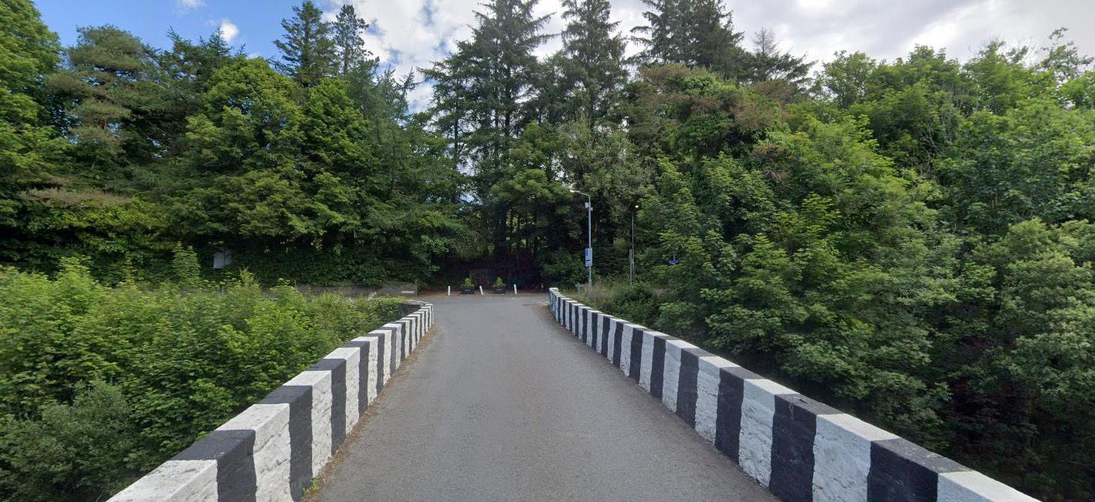
The southernmost junction at the Pinwherry bridge for abnormal indivisible loads (AIL).

• The proposed AIL delivery track would remove below ground foundation remains of the heritage asset 204859 Pinwherry Tolhouse where it leaves Main Street in Pinwherry. The AIL access point will be temporarily decommissioned on completion of construction for the duration of the operational phase of the proposed development. An earth bund with planting will be formed to block this access point and provide screening from the A714 which can be removed if future access is required e.g. if a wind turbine burns down and needs replacing! This, presumably, would also be the access when they apply for the inevitable extension to bring the wind farm back to the original number of proposed turbines.

• A network of new (10.7 km) and upgraded (up to 7.3 km) access tracks are proposed throughout the site totalling up to 18 km, nearly 6 km of these are over deep peat (> 1 m in depth).

3. Hydrology
• Deep ground work for turbine bases and borrow pits allow access to the numerous faults (fractures) and dykes (intrusions) which criss cross Scotland (this site is particularly close to the Glen app Fault) and act as conduits for ground water. Pollution from site work could potentially very easily access the aquifer and pollute water supplies. There is one licensed abstraction and 19 private water supplies (PWSs) within the study area. Many rural homes will never have the opportunity to access mains water. PWSs are, therefore, incredibly important to families living in these outlying properties.

• A number of watercourses drain the site to the River Stinchar to the north and the Muck
Water to the south. The site comprises predominantly commercial forestry plantation with some pasture, on higher ground between the River Stinchar to the north and the Muck Water to the south. It is drained by a number of these rivers’ tributaries including the Balligmorrie, Drumneillie and
Fortypennies Burns and the Docherniel and Glake Burns respectively. Within the site boundary there is a high to medium likelihood of flooding further downstream, most notably across the flood plain of the River Stinchar.

• The estimated amount of concrete required for the construction of each turbine foundation is
975m³ (a total of 15,600m³) with a further requirement of 375m³ for construction of the substation and ESS compounds and other foundations, an overall total of approximately 16,000m³. (That’s a total of about 37,000 tonnes) Onsite concrete batching is required and is proposed to take place in one of the borrow pits. It is a noisy, dusty and water-intensive business. The water will either come from onsite sources (an abstraction licence is required) or be hauled in by road. nb. South Ayrshire is on a moderate alert risk (as at 15 June 2023) regarding water scarcity. Southwest and central Scotland are continuing to experience very low river levels and a further drying of ground conditions. If rivers remain at very low flows for more than 30 consecutive days there is a heightened risk of severe, long-lasting ecological impact.

It's worth copying any objections or concerns relating to water to South Ayrshire Council and SEPA:
planning.development@south-ayrshire.gov.uk
constance.lobban@south-ayrshire.gov.uk (re. private water supplies)
planning.sw@sepa.org.uk

4. Aviation lights
• Wind turbines at 150 m and above require aviation warning lights. The outer turbines of the proposed development require lighting and include T2, T3, T10, T12, T15 and T16. Turbine lights can be seen over considerable distances, with some clearly visible at 20-30 km. The proposed development is just outside the Buffer Zone (but within the Transition Zone) of Galloway Forest Dark Sky Park and Galloway & Southern Ayrshire UNESCO Biosphere. Turbine lighting is highly likely to reduce the dark skies in this area and risk the Park's important 'Gold Tier Dark Skies Park' status.

• Regarding Landscape Capacity as issued by South Ayrshire Council. 18a: "While some scope may exist for new development to the north of the Duisk Valley, the pronounced sense of remoteness experienced in this densely forested and very sparsely settled area would be likely to present a major constraint for development, and particularly for turbines >150m high which would need to be illuminated and would thus impact on dark skies." (South Ayrshire Landscape Wind Capacity Study, 2018)

• It is claimed no significant night-time effects on landscape character or designations, and no significant night-time effects on views from settlements and transport routes. However, once the forest screening has been felled there would be significant effects on White Knowes Cottage, Right of Way SKC3 and Scottish Hill Track 68 in the Muck Water Valley near Mark Farm, which is the nearest residential property to the site, located approximately 500m beyond the site boundary to the south.

5. Noise
• The effect of operational noise has been assessed as not significant. The noise report was prepared using antiquated ETSU-R-97 guidelines and supported by dated research to shore up spurious claims that turbine noise does not cause health problems. The proposed development is south of Hadyard Hill Wind Farm and north of Mark Hill Wind Farm, both of which already have noise issues.

6. Shadow flicker
• Of the 27 properties identified within 2.5 km of the turbines, fifteen have the potential to experience shadow flicker and two properties are predicted to experience greater than ten hours of shadow flicker per year. An assessment of cumulative shadow flicker effects has also been undertaken, which has identified that four properties may experience cumulative shadow flicker effects as a result of the proposed development and other wind farm developments in the area. Of these, one property is predicted to experience greater than ten hours of shadow flicker per year. Where shadow flicker levels exceed the guideline threshold levels, mitigation is to be employed.

7. Forestry
• The site where the turbines will be located is largely commercial forestry. Advanced felling of 356.2 ha of forest will be required. This equates to the felling of 712,400 trees (calculated at a commercial planting rate of 2000 trees per ha). There will also be an overall woodland loss of 72.1 ha.

8. Tourism
• The proposed development’s economic and employment effect relating to tourism, an important industry in this area, is assessed as negligible. This assessment relies on a report by Biggar Economics entitled 'Wind Farms and Tourist Trends in Scotland' (2021) and dated research from Visit Scotland (2012). Among the many issues with the Biggar report is the fact that data does not differentiate between jobs supported by tourism and those supported by local residents or workers. If tourism cannot be separated from other sectors, it cannot be properly measured. No robust independent research has been carried out on tourism and the wind industry to date.

9. Energy
• Large volumes of wind energy continue to be discarded (Constrained) in Scotland to preserve grid stability. Adding further wind capacity in Scotland appears to be of low marginal benefit. Additional capacity has a high probability of some of it being constrained off. The proposed wind farm development has not taken the potential for constraint payments into account. It is likely, therefore, to have over-estimated its actual benefits of generation by between 10 per cent and 20 per cent.

Below are examples of the total amount of energy constrained and payments made to nearby wind farms up to 2 March 2023. Data is taken from the Renewable Energy Foundation (REF).

Wind Farm MWh Cost/£
Assel Valley 43,859 3,068,039.00
Hadyard Hill 434,281 30,722,300.00
Mark Hill 141,375 9,434,295.00

Slightly further south, but within 20 km, of the proposed development even larger payments are being made to other wind farms. Kilgallioch, for example, has claimed a total of £54,407,071.00 since it became operational in 2017! If nearby wind farms are constantly being constrained, so will the proposed development.

• The Scottish Government's new Onshore Wind Policy Statement (OWPS) published in December 2022 states that the target for onshore wind is 20 GW by 2030. As of June 2022, Scotland had 8.7 GW of existing onshore wind energy and 11.3 GW in the pipeline (5.53 GW in planning; 4.56 awaiting construction; and 1.17 under construction) (OWPS, 2022 pg 5). Scotland has met its 2030 target. This data excludes the huge amount of offshore wind energy production in the pipeline.

• Not only has the energy target been met, there is an oversupply of power. This poses a problem because the grid cannot handle the wind power being produced. Excess energy is exported to England but existing transmission connections southward provide only 6.1 GW of capacity leading to 17 per cent of all wind farm output throughout Scotland being curtailed annually. While the National Planning Framework 4 (NPF4) states that "Grid capacity should not constrain renewable energy development." (pg 54), if all targets have been met, and even exceeded, these constraints should be treated as material consideration against the proposed wind farm development.

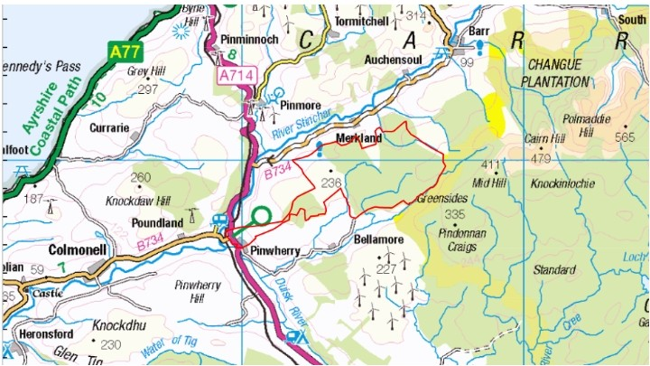

Site location of the proposed Knockodhar Wind Farm outlined in red

