CP6 – go between

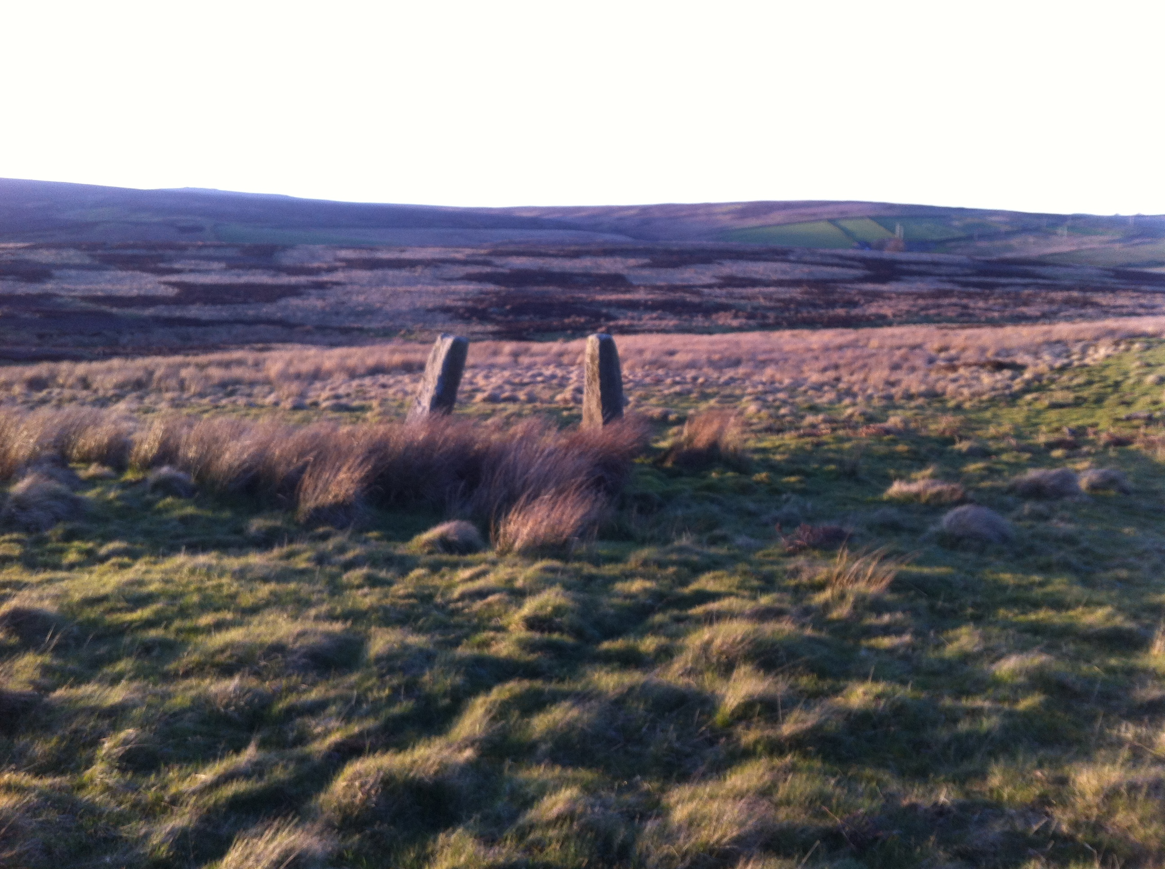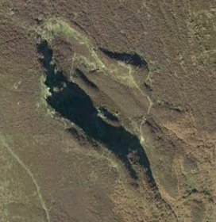

CP3 Quarry

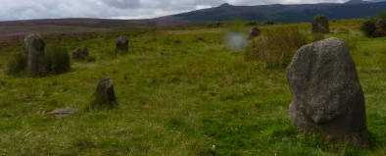

CP1 Stone circle

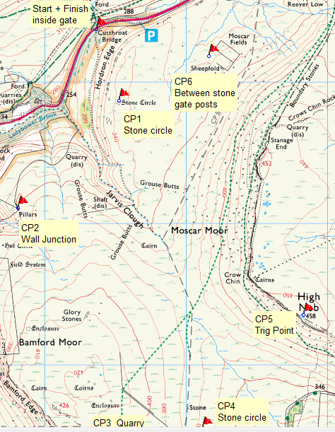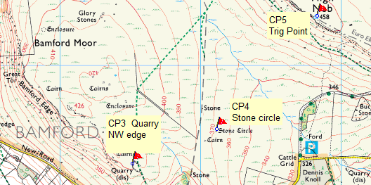

Start + Finish by gate across from Cutthroat Bridge

CP6 solo stone gateposts must go between.

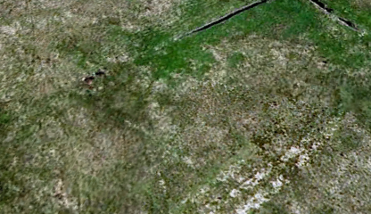

CP1 Stone circle

CP2 Wall junction

CP3 NW edge of quarry

CP4 Stone circle

CP5 Trig point

CP6 Through two loan large stone gate posts

Finish

CP4 the heather has since been burnt off.

