TWO DAYS IN THE LIFE OF NICKY SPINKS
OR
NICKY’S DOUBLE BOB GRAHAM RECORD

Introduction
When I was in hospital at the end of June 2015 following my operation for a new right hip, Nicky sent me a card and enclosed was an account of Roger Baumeister’s double Bob Graham round and record which he completed in July 1979. Interesting I thought – does this mean that Nicky is going to make an attempt? Sure enough, when we next met up she confirmed that she had been thinking about the double for some time. I was fascinated by the logistics of Roger’s double round and so much seemed to make perfect sense with only one visit by the road support to Wasdale and only one requirement to rig Broad Stand.
The Plan
In time Nicky made her ambitions for the double known to a relatively small group of potential supporters and asked us to confirm our availability for her preferred dates of 14/15 May 2016. There was a brilliant response and so it was game on and we were all asked to keep it quiet so as to limit the pressure of widespread publicity before the event.
Preparation
As is Nicky’s way, she then spent many days in the Lakes reccying each of the legs in the anti-clockwise direction and picking the brains of other close friends who had completed BG’s ACW. Gradually her schedule came together and she allocated supporters to each leg, asking them where possible to do the same leg in both directions.
The Big Weekend
Steve and I drove up to Thornthwaite on the morning of Friday 13th May and I booked in at the campsite where I asked the farmer if he knew what Nicky was planning (Inov-8 had by now broken the news). He laughed and said he knew that she was up to something!! Nicky arrived at lunchtime and we spent a couple of hours going through all the bags of food and clothes, agreeing changeover locations etc. Nick from the film crew turned up and did some preliminary interviews before Nicky retired to her van for a sleep/rest whilst I made lots of notes and briefed supporters as they arrived and handed out supporters bags of food and drinks.
As the A591 had been closed at Thirlmere we had agreed that Richard Hakes accompanied by Roger Baumeister would cover the Dunmail Raise changeovers for me which would enable me to get to and from Wasdale in enough time for Steve and Dave to go up and rig Broad Stand. I therefore gave Richard the bags for Legs 3 and 5 and a bag of spare Nicky clothes.
The Start
Before long it was 11pm and Nicky came to the van with Jasmin for “breakfast” of large bowls of porridge. We all drove to Keswick and waited for the off at Midnight when a small group saw Nicky head off into the night accompanied by Jasmin and Steve Sanders. I drove up to Threlkeld with Wisp the dog and parked down the lane to try to get a bit of sleep but as usual I was totally absorbed by checking the tracker at regular intervals, knowing that reception can be patchy back of Skiddaw.
Kirsty, Jean and mark arrived and they shared out the supporters’ bag and Kirsty agreed to take charge of Nicky’s head-torch which would require a new battery for the return leg 5. Soon lights could be seen descending Halls Fell and before long Nicky was in the van, eating beans on toast and rice pudding and drinking tea and coffee. A quick pit-stop and she was off again with Wisp, excited at being allowed out to play, and I could look after Jasmin and Steve. Suddenly there were lights approaching and we thought it must be another BG attempt but it turned out to be the cameraman who should have been on Clough Head to film Nicky. Gutted to have missed them he had a cup of tea and we all returned to Keswick.
I collected Steve and Dave (plus ropes, ladder etc) from the campsite and Steve drove round to Wasdale where I called at Joss’s cottage to let him know how Nicky was doing. We had chatted to him a few weeks earlier to let him know what Nicky had planned as he had supported Roger on his double round 37 years earlier. We got parked up and Steve and Dave set off up to Mickledore, pausing to have a photo taken with a bucket and chamois.
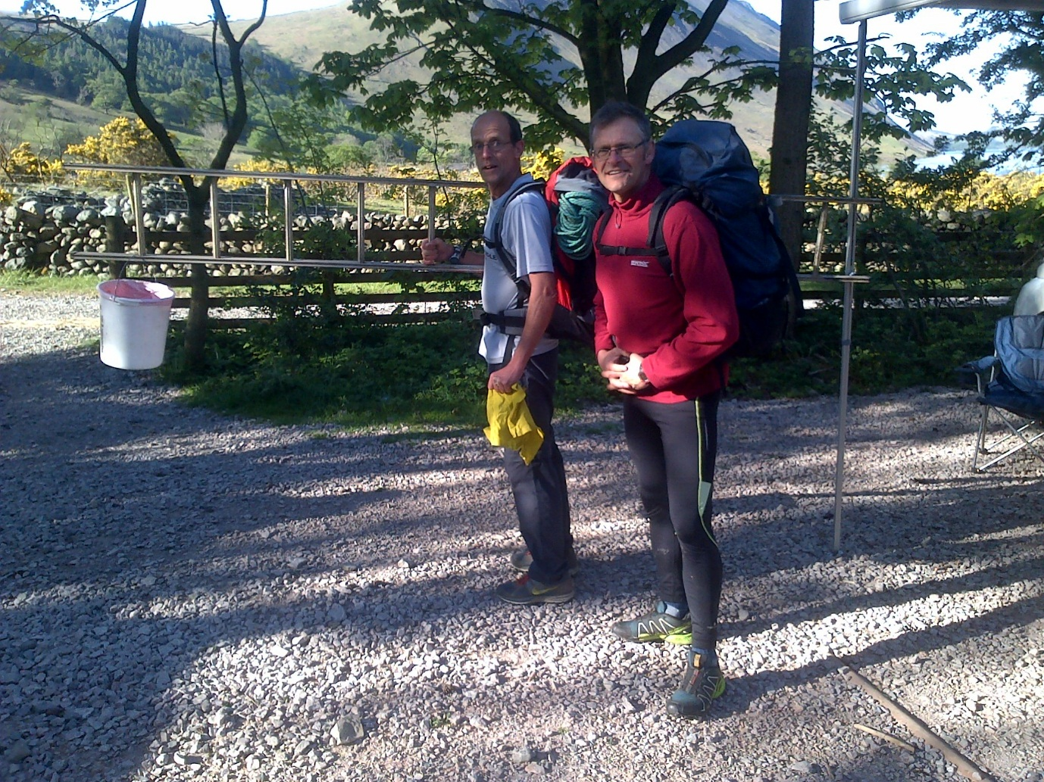
Asked by bemused walkers what they were doing they said they were off to polish rocks and knock some rough corners off in line with Health and Safety!!
As I have no access to the tracker in Wasdale, I was waiting to get text updates when Justin ran down from Scafell. He picked up another rope and walked up to Mickledore with Nick the cameraman. I rested for a while and then got roast potatoes, cheese and onion pie and gooseberry crumble in the oven ready to feed the Leg 3 supporters who would be returning to Dunmail on Leg 4. Justin ran down from Mickledore to tell us they were on their way and soon we saw Nicky, accompanied by Joe, Glen and Dave and Tim (who had gone up to meet them) making good progress down towards the field where the Wasdale fell race starts. Kettle on, and there was a quick stop before Nicky and Tim headed off for the Yewbarrow hill rep. The Leg 3 supporters sorted themselves out and I re-supplied their Nicky provisions whilst they fed their faces and changed their clothes.
Joss arrived in time to watch Nicky and Tim cresting the brow of Yewbarrow and we chatted whilst enjoying the glorious sunshine and waiting for our intrepid heroine to return.
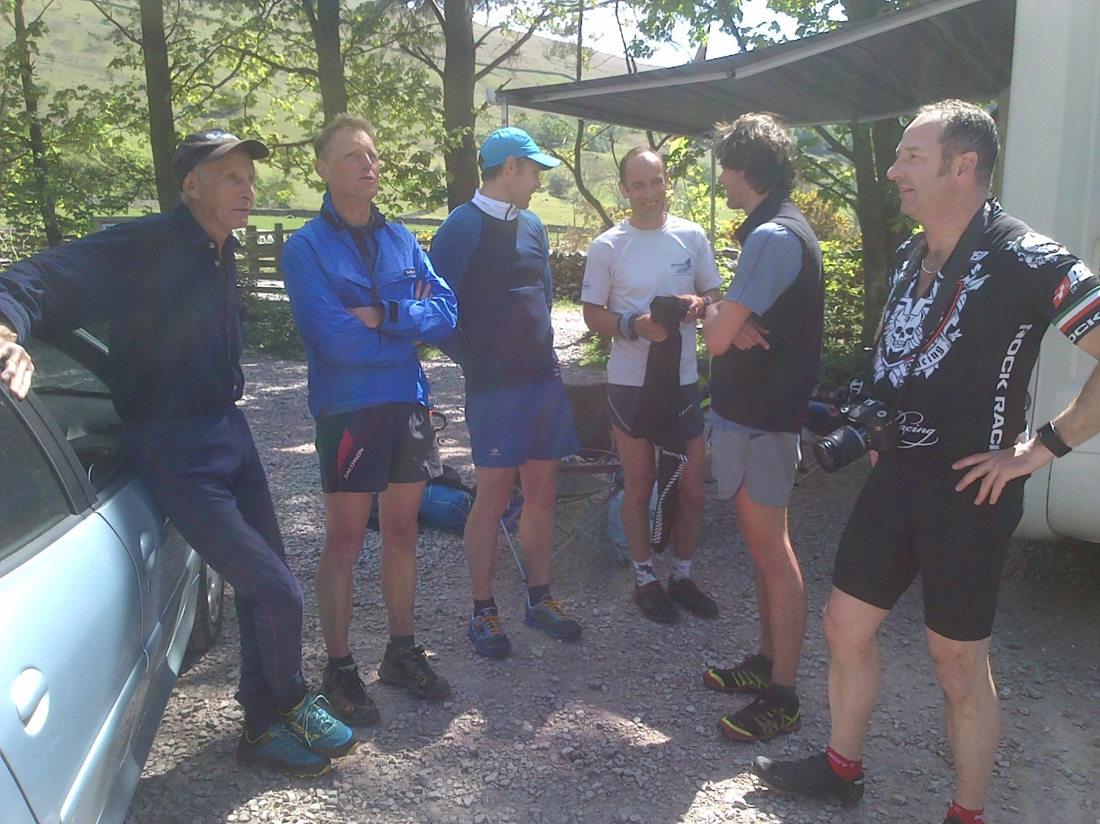
It wasn’t long before Nicky and Tim could be seen descending towards us and the cameraman got in position, having to move at the last minute as Nicky ran up the car park to see Joss waiting with a bag of fudge to fuel her on her way. Her face was a picture I gave her a plate of cheese and onion pie, roast potatoes and beans whilst I removed her shoes and changed her socks with a liberal dose of foot powder. Good wishes all round and they were off again and Joss commented how strong her l’aal legs were climbing Scafell.
Joss told me that he would like to run through to Keswick the next day and we agreed that I would ring him at 8am to keep him updated as he doesn’t do these new-fangled tracker things. I started to tidy up and a returning walker told me that I had been washing up when he left 5 hours previously. After a couple of hours, Steve and Dave returned weighed down with all the climbing gear and asked if there was any food left. We polished off the rest of the pie and crumble before Steve drove us back to the campsite where I hoped to get a few hours sleep between 7 and 11pm.
We settled down and I was woken at 9:30 by my phone ringing. It was Adam Perry who was joining us for Leg 6 and I confirmed the location of the changeover where he would grab a bit of sleep in his van. We checked the tracker to see that Nicky was 2.5 to 3 hours up on her schedule and we got ready to move up to Threlkeld where Dave was going to join Adam and Jasmin (who was already on the hill with Kirsty and Jean) on support. We thought that Nicky may want a power nap and so took Dave’s van for the other runners to keep warm in. I set about brewing up and making beans on toast whilst Dave and Steve walked up Clough Head to guide them down to the lane. When I saw lights descending I woke Adam and soon Jean was running around the corner with an order for beans and tea and no power nap. Nicky arrived, troughed and then promptly lay down and closed her eyes for a few minutes before heading off up towards Halls Fell with Dave from the flatlands in the company of giants . It was then that Kirsty revealed that she had never eaten a banana and when given one for Nicky had no idea how to “open it”. We sat and had a cup of tea before there was a knock on the door. Once again the cameraman had missed all the action!
Then it was back to the campsite with Wisp for a shower and freshen up before heading to our agreed rendezvous point on the Keswick side of the suspension bridge from Portinscale where we met up with Keith Holmes who had driven up from the Peak District after a very early start. Soon the other supporters for Leg 7, Helen, Simon and Wisp the dog, together with various spectators and well-wishers were gathering and Richard kept them all supplied with tea whilst I got ready to fry eggs at the drop of a hat. We saw the Leg 6 team running up the field paths and soon Nicky was in the van and tucking in to her fried eggs and beans on toast. I knealt down to take off her shoes and looked up to see tears rolling down her face. This was a low point as she tried to come to terms with another 14+ hours to do. Taking advantage of the quiet van she had a complete change of clothes and then snuggled up under a blanket with an instruction to be woken in ten minutes. Simon and Tim had posted a link to Nicky’s Just Giving page with an appeal for donations and the money started to flood in. This was a great motivational influence which helped to drive Nicky on.
There was little moment of indecision as Nicky emerged from the van and briefly turned right towards Keswick. Maybe she had dreamed that she had already run the second loop! Then she was off towards Portinscale and the second part of her journey. We all relocated to Honister where there was some confusion as to which car park we would base ourselves and I set about re-supplying the Leg 8/9 support team. The Leg 3/4 team had inadvertently picked up the Leg 5 bag which had been replaced by the Leg 8 bag and so I gathered all the left overs plus a food flask of ratatouille and flasks of tea and coffee for this very long section. I told Willy, Laurence, Beth and Matt that Joss was intent on meeting them at Dore Head and Tim acted as our spotter watching for the Leg 7 team descending from Dale Head. This time the van was too hot and Nicky ate her eggs and beans outside whilst Willy took her sun cream. As they set off, Kirsty and Jean arrived as they were going to run through with extra coffee supplies.
Then it was back to the campsite once more to follow the tracker, drink tea, eat cake and doze in the sun. Steve, Dave and Dave took themselves off to the pub. Then I received a phone call from James at Open Tracking as Nicky’s tracker was down to 18% battery life and he asked me to contact her support team to exchange her tracker for the spare. I managed to get through to Willy who was brewing up whilst Nicky went up Steeple. I stayed on the phone to confirm that the trackers had been changed before letting James know that Tracker 1 went up Steeple and that the feed could now be swapped to Tracker 2. Mission accomplished – phew!
We agreed that we should go back to Honister for 5pm to be ready for the final changeover where Dave Lund bought ice creams. The cameraman was halfway up the hill and we had a false alarm when a group of runners appeared over the horizon. The cameraman rushed over to discover that it was another lass towards the end of her single round. Then we spotted the unmistakeable outline of Joss on the skyline and watched in admiration as he ran down towards us with his home-made poles. Kirsty and Jean also ran down to tell us that Nicky and team were not far away and they were soon heading down the grassy slope. It was a very quick stop for spicy sausage and beans before the Leg 10 supporters and Wisp set off for the final push after Nicky had a big hug from Joss, who jumped in the van with us to ride around to Newlands. It was also great to see Steve Cliff who had run up to join Nicky on the final home straight.
We had a last look at the tracker and I showed Joss that Nicky was approaching Hindscarth before we headed up the valley to Newlands. The atmosphere was electric and we applauded the lass we had seen at Honister as she ran through. The cameraman got in position in the back of his van and soon they were off, filming Nicky as I tried to keep out of shot whilst blocking any other vehicles from overtaking. When we got to Portinscale I peeled off and shot round to Keswick where we and a huge crowd didn’t have long to wait before Nicky came sprinting up to touch the Moot Hall and stop her watch at exactly 21:30 and just 45 hours 30 minutes after she had set off to claim the first female double BG and the new all comers record.
There were lots of photos taken and it was magic that Roger and Joss were there on hand to offer their congratulations. Chips and curry sauce were ordered and Nicky sat down on a bench to take it all in and bask in the well-deserved glory before we headed off back to the campsite. Many thanks to Max and Lynda who took Joss back to Wasdale on their way back to their campsite at Ravenglass. Back at the campsite Nicky headed to her van which promptly locked itself with her keys inside. So she had a shower and got her head down in our van whilst we waited for the breakdown man from Egertons who skilfully retrieved the keys at 1am and we all got some well overdue sleep.

